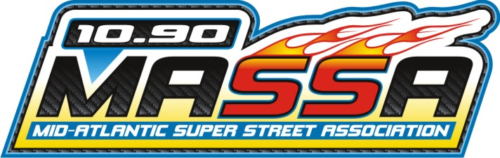

Mid Atlantic Super Street Association
2020 Membership Form

New Member Renewal Membership

Participating Member: $80.00 for the season

Please Print

Full Name: __________________________________________________
Mailing Address:_____________________________________________
City, State, Zip: ______________________________________________
Phone #: ( )_____________________________________________
E-Mail Address:______________________________________________
NHRA Car Number:_________________________________________
T-Shirt Size: ________________________________________________

Please make all checks payable to:
Mid Atlantic 90 Association

Please return completed form along with annual fee (80.00) to:
Rob Keister
865 S. Orchard Rd
Vineland, NJ 08360
www.midatlantic90.org

